React

Installation

Npm I -g create-react-app

Create-react-app uhk

If ur name has space so remove it by following command then run npm otherwise it will giv error

Npm config set cache “c:\user\usama~khan\folder”—global add tlda replace space

If u don’t wana install just run react so use

Npx create-react-app uhk

Public 🡪index.html where ur html which is added by other file using component

Src ->app.js where components are built

U have to import folling in app.js

*import* React, { Component } *from* 'react';

*import* Header *from* './components/Header'; its made by me manualy

*import* logo *from* './logo.svg';

*import* './App.css'; its css file

app.css its css file where u add ur css

index.js where u tell which component is renderd in to which html tag

*import* React *from* 'react';

*import* ReactDOM *from* 'react-dom';

*import* './index.css';

*import* App *from* './App';

*import* * *as* serviceWorker *from* './serviceWorker';//thisisused for offline loading

*import* 'bootstrap/dist/css/bootstrap.min.css'; /add bootstrap here by me

ReactDOM.render( //its takes tow component one is compnntn and 2nd is where u wana add this compont like html tag

  <React.StrictMode>

   <App /> //export default name which is in app.js file

  </React.StrictMode>,

  document.getElementById('root')

);

*// If you want your app to work offline and load faster, you can change*

*// unregister() to register() below. Note this comes with some pitfalls.*

*// Learn more about service workers: https://bit.ly/CRA-PWA*

serviceWorker.unregister();

pacakage .josn where all packages name writren and version as well

**node-module** where all packeges are install if u delete it u can dllt all akcege which is in side of t by typing npm istall it will install only thode package which is inisfd of it

components

there are two types of componnet one is function other s class

function is new class os old

**class**

**class App extends React.Component{**

**render(){**

**return(**

**<div className=”app”>**

**<h2>this is me</h2>**

**</div);**

**Export default App;**

**or u can writ it on start of class class App extends React.Component{**

**2nd way of clalss**

**class App extends React.Component{**

**render(){**

**return(**

**React.CreateElement(‘div’null,React.createElement(‘h2’,null’,”wao its nice”);**

**React.CreateElement(‘div’null,React.createElement(‘h2’, ,{className:’App’},**

**,”wao its nice”);**

**,{className:’App’},**

**function**

function App() {

   return (

     <div className="App">

      <h1>Bismillah hir rehman e reheem  ths is uhk</h1>

   </div>//   );// }

**u can use short cut by replace app.js with App.jsx**

**h1*5 other wise it will not word**

**how to add bootstrap**

**intall bootstap by**

**npm install react-bootstrap bootstrap**

**search react bootstrap then add**

**either cdn link or import in to index.js**

**first u have to install it by using npm install react bootstrap**

**header=incorrorect it act as tag**

**Header =correct act as component**

**<img/>its closing tag if u dint /in end so it will give error in closing tag html pick it by self if u don’t put but not react**

**Path**

**C:\Users\Usama Khan\Videos\React-learning-by -uhk\React-learning\uhk2>**

**C:\Users\Usama Khan\Videos\React-learning-by -uhk\React-learning\uhk2>**

**Add components files**

**Add folder to src**

**Person ->persn.js**

**In person .js**

**U have to create componntn u can create class compont function cpmponnt or arrow finction component**

**Fist add**

**Import React from ‘react’**

**Var person =()=>{**

**Return(<h1>nice</h1>);**

**Export Default person**

**Now add this in to app.js <person/> or <person><person/>,fosrt add this compontn**

**Import person from ‘.person/person’; person.js don’t need to write js it pick automatic**

**Props**

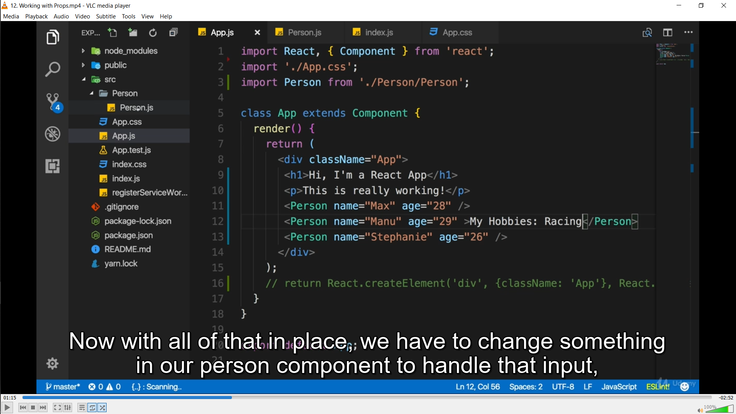

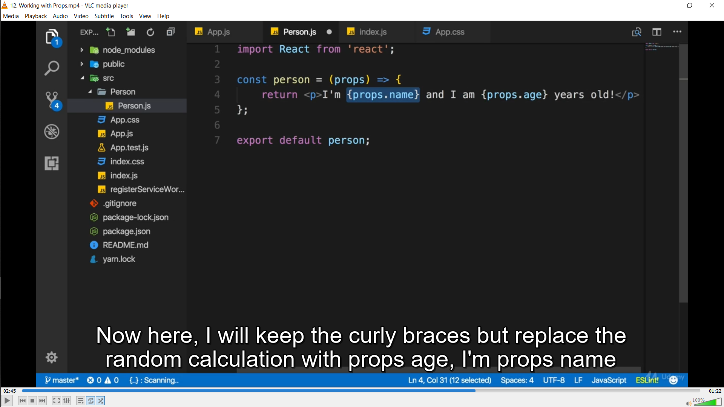**s**